PWCS VHS | Name:

Module III: Ancient Egypt
Directions: Read the background essay and analyze the five primary sources below. These will help you discover how the Nile shaped Ancient Egypt. Type your responses directly in this document, save the file (III.2_LAST NAME) and submit it to the dropbox.
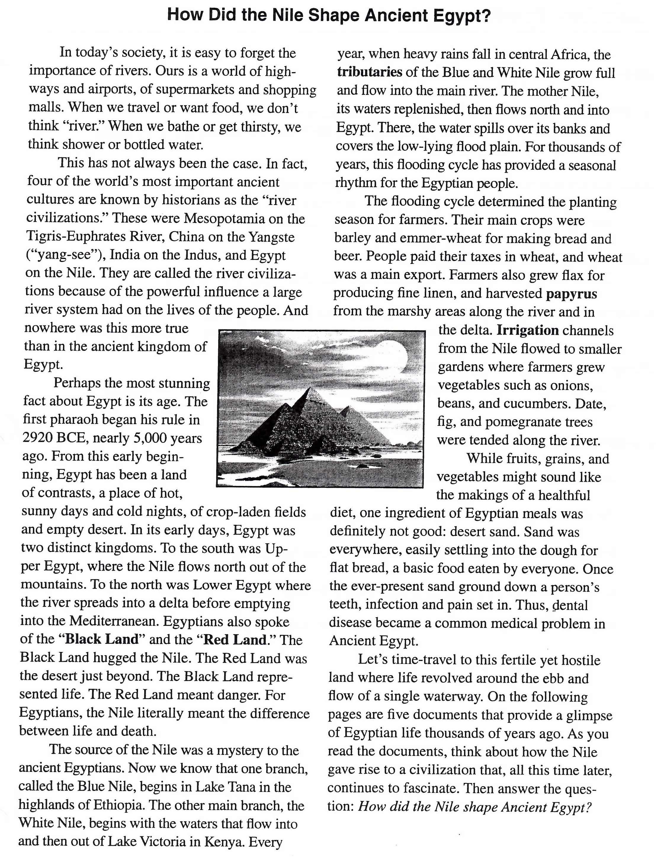
Document A
(Source: Map created from various sources)
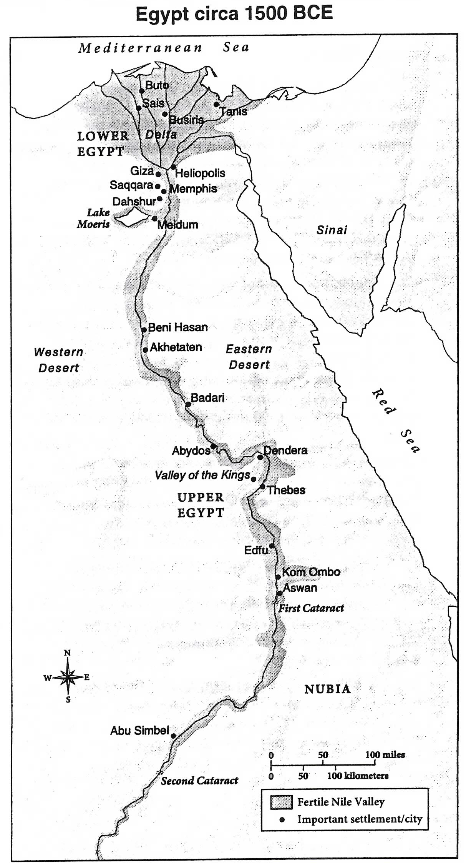
Document Analysis
- The Nile is the world’s longest river, 4,160 miles. Consider the southern boundary of Ancient Egypt to be at Aswan (the first cataract, or rapids). About how many miles of the Nile are actually in Egypt?
Out of the 4, 258 miles of the Nile, there are about 900 miles that are actually in Egypt

- Why is the delta region to the north called “Lower Egypt”?
Before entering into Mediterranean, the river spreads into a delta. The elevation difference makes it to be called lower Egypt and therefore the Nile flows from south of Egypt to the North of Egypt.

- What were the eastern, western and northern boundaries of Egyptian settlement?
The eastern boundary was the Dead Sea eastern part, the Mediterranean sea was the western boundary and the city of Carchemish was the northern boundary

- Given the geography of this area, do you think Egypt was vulnerable to foreign invaders? Explain your thinking.
To foreign invaders, I think Egypt was actually defended easily. On three sides most of all, the desert protected it which made it impossible from any direction other than the North to attach Egypt.

- What do you notice about population distribution and settlement location in Ancient Egypt? List three or four reasons for this.
In Ancient Egypt, population was along River Nile. This was due to the fertile soils, most of the land was desert and water was used for irrigation.

Document B
(Source: Chart adapted from Katherine Hinds, Life in Ancient Egypt: The Countryside, Marshall Cavendish Benchmark, 2007.)
The Nile River Flood Cycle
Akhet (flood season)  Mid-June to mid-October | Fields in the Nile floodplain covered in water and fertilized by a new batch of silt. Time when many farmers worked off their public-labor tax, doing jobs like canal repair or quarrying.
Peret (planting and growing season)  Mid-October to mid-February | Water receded but Nile high enough to fill irrigation canals, crops planted and tended.
Shemu (harvest season)  Mid-February to mid-June | Crops in the Lower Nile harvested and sent to market.
Note: The average rainfall, historically and today, has remained about the same. The Nile delta receives about four inches per year. The Nile Valley south of Cairo receives less than one inch. In comparison, Atlanta, GA, gets about 50 inches of rain annually and Phoenix, Arizona, about eight inches.
Document Analysis
- What differences do you see between Egyptian seasons and the standard seasons in much of the United States today?
For the seasons every year, they get more rainfall which led to the Nile River flooding and which in the United States does not happen.

- Usually the flood season produced a “good Nile,” just the right amount of water. What might be the consequence of a “bad Nile” – too much or too little water?
A bad Nile consequence might be famine from crops dying and property destruction from water flooding

- The population of Ancient Egypt was probably about one million, 95 percent of whom were farmers. According to the chart, when were farmers busiest?
In the flood season, it’s when the farmers were busiest since they did jobs like canal repair or quarrying.

- When would this large work force of farmers be available to work on government projects, like building palaces and tombs?
In the planting and growing season since it’s when farmers were not busy

Document C
(Source: Illustration by Oliver Frey in Living in Ancient Egypt, Norman Bancroft Hunt, editor, Thalamus Publishing, 2009.) 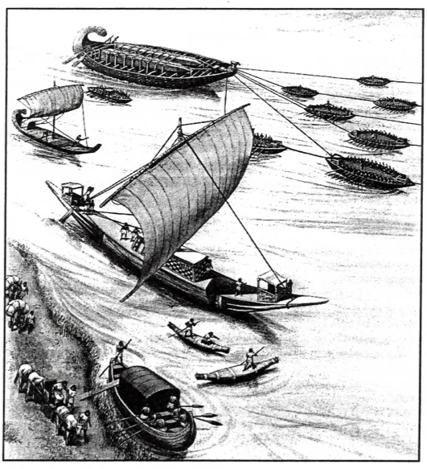
Note: The Nile River flows south to north against the prevailing northerly wind. In ancient times, boats traveling upstream against the Nile current used a sail or rowers or both. Boats traveling downstream to the north often just floated with the help of steering oars. The Nile current was about four knots (4 mph) during flood season. It slowed to a sluggish one knot (1 mph) during the rest of the year.
Document Analysis
- What is being transported by the barge (the vessel pulling the tugboats)?
Substantial loads were the ones carried by the barge.

- What is likely being carried by the large sailboat?
The harvests from the land are the ones being carried likely as a result of irrigation

- What direction are the sailboats, barge, and tugs traveling? Explain your reasoning.
North. This is because of the prevailing northerly wind therefore flowing against

- Drawing from evidence in the document, what are five occupations in Egypt that depended in some way on the Nile River?
Fish for food, drinking water and bathing, crop irrigation, materials for paper and building were furnished by the reeds. Moreover for transportation, the river was also important.

Document D
(Source: Painting from the tomb of a tradesman named Sennedjem, who lived sometime between 1307 and 1196 BCE.)
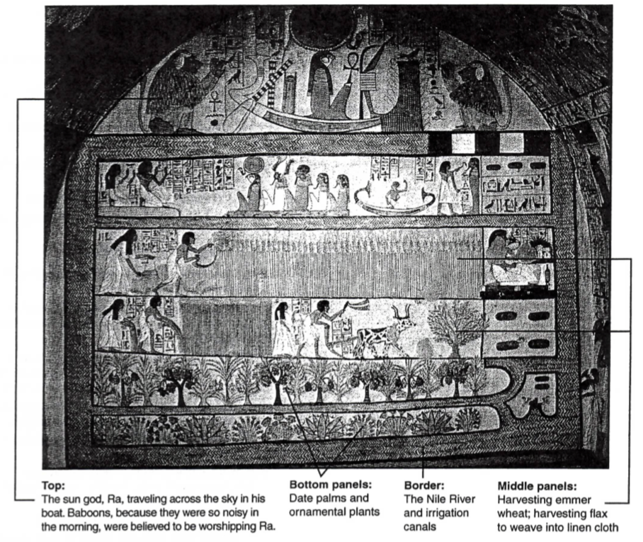
Note: The afterlife in Ancient Egypt was a paradise called the Field of Reeds, shown in this tomb painting. Those whose heart had the correct weight at death could, after a long journey, live in the Field of Reeds forever. The Field of Reeds was believed to be somewhere in the east, near the rising sun.
Document Analysis
- The middle panels of this tomb painting show the deceased and his wife engaged in various activities. What kind of activities are they?
The kind of activities they are engaging in are ploughing the land.

- What natural and man-made objects can you identify in the bottom three panels?
The natural objects are the reeds and irrigation canals are the man-made objects

- What would disappear from this picture of paradise if the Nile weren’t present?
Wheat harvesting would disappear if the Nile weren’t present since were it not for the available water for irrigation, such an activity will not have come into being.

Document E
(Source: From the song “Hymn to the Nile,” circa 2100 BCE.)
Hail to you, oh Nile,
spring from the ground, come to keep the land alive…
who floods the fields that Ra [sun god] has created
to make all the animals live…
who produces barley and makes wheat grow,
that the temples might be in festival.

If he is sluggish, noses suffocate,
everyone is impoverished…
If he rises, the land is exultation,
and everyone is in joy.

Document Analysis
- What is a hymn?
A hymn is a song of raise

- According to the “Hymn to the Nile,” why do the Egyptian people praise the river?
The people praise the liver because it is through it that the land is given life and through this animals are able to live and also the river produces food for survival.

- What is the one “bad” behavior of the river that is mentioned? What is the result?
Slugging. The result is that peoples noses suffocate

- The famous Greek historian Herodotus once wrote that “Egypt…is, so to speak, the gile of the Nile.” What did he mean and was he right?
What he meant is that Egypt soil is so fertile and good because of depositing by Nile of its sediment onto it. He was right because Egypt without Nile would be a desert

